**WORK INSTRUCTIONS FOR** **TAPPING OPERATION (BF1 & BF2)**

**Responsibility: Furnace Incharge /Foreman/Sr. Tap hole operator / Tap hole Operator**

**Identified Hazards:**

1. Contact with hot metal and slag
2. Contact with hot metal while poking the taphole
3. Contact with hot metal while pushing the sand/rice husk
4. Fall of Person
5. Fall of person while pulling the jam
6. Electric shock
7. Mechanical –Impact
8. Slipping in the runner
9. Slipping in the runner due to failure of poking rod at welded joint
10. Mech. Impact by drill machine
11. Mech. Impact by mudgun
12. Mech. Pressure
13. Contact with hot metal sparks
14. Contact with hot water
15. Entry of hot metal & slag on cast house platform
16. Bricks worn out of ladle
17. Nonuse of PPE &WI
18. Improper house keeping
19. heat
20. Noise induced hearing loss
21. Vision impairment due to glare of hot metal
22. Dust obstructing lungs disease
23. Runner leakage
24. Improper job posture
25. Not evacuating persons working in the area in front of taphole in Hot metal crane bay
26. Use of welded poking rod
27. Opening of taphole on its own
28. Puncture of hose pipe leading to flooding of main runner.
29. Bending while tapping/Muscular strain
30. Uncontrollable metal flow from taphole leading to injury/damage
31. Opening casting/diverting metal without placing ladle
32. Graphite particle entering into operators’ eyes.
33. Smoke coming out below metal spout area
34. Ladle puncture
35. Wet runner due to water leakage from tap hole resulting into metal eruption after opening cast
36. Un alertness in surrounding area of people around
37. laddle hood trolley operation failure

**Non-Standard tools used**

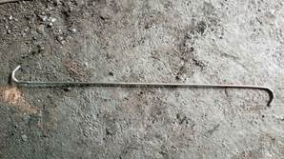 **Hook**: - usedfor cleaning jam

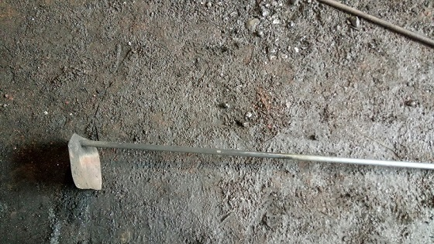 **Powda: -**Used for diverting slag & metal

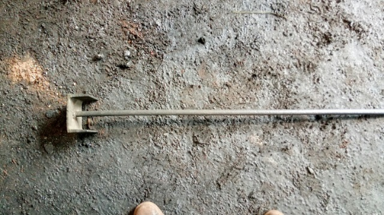 **Rammer: -**Used for manual ramming with less weight for spout preparation

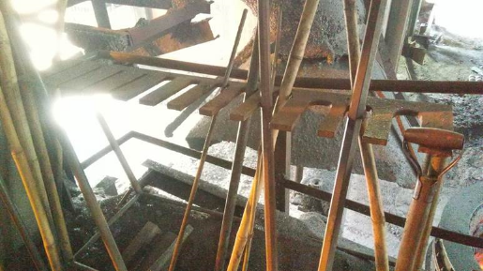 Crowbar stand

**Significant Aspect:**

### Generation of graphite dust

Heat generation

1. Unauthorized operation or repair of any equipment is a punishable offence
2. Ensure that the personnel involved in the activity uses safety appliances (PPE) viz. Safety helmets, safety shoes, hand gloves, safety goggle, leg guard, woolen Patti, full sleeve cotton/jean shirts and taphole operators should wear safety overcoat & helmet with screen while opening the cast.
3. Ensure that all personnel involved in the activity are trained in safety awareness including contractor workmen. Sharp edge on the angle Covered.
4. Ensure proper position & posture for performing the task.
5. Check the taphole center with the help of gauge and adjust the center if it is off centered. Use Metal grating to avoid accidental slippage into main runner.
6. Operation of mudgun to be checked at least 15 mins before opening of the cast. Take the mud gun trial before opening the cast with filled anhydrous clay in the barrel. Ensure all concerned are clear from the swing area of the Mudgun and area is barricaded. (ref. WI/PROD/08B for mud gun operation) Ensure that empty ladle is placed below the runner spout in such a way that hot metal should fall at the center of the ladle without hitting the side wall brick before opening the cast. Ensure Proper House Keeping to maintain around vicinity of ladle hood trolley movement area. Ensure that ladle hood is positioned above the ladle where liquid metal is intended to be taken and also place the ladle hood onto the second ladle using the electrically operated ladle hood trolley before diverting the metal in to the second ladle. The ladle hood is connected to the de-dusting system.
7. Ensure skimmer plate hole size before opening of cast. Ensure that skimmer plate hole is free of any of the material and clear before opening of cast.
8. Before opening of the cast, please ensure there is no inflammable material, human, or any equipment in the EL runner as well as EL area and slag pit. Ensure EL area is properly barricaded with slag so that hot slag will remain in the EL area only. EL area should be always dry. No accumulation of the water is allowed. Please refer work instructions for EL preparation.
9. Ensure there is no persons or equipment in the slag pit and slag pit is properly barricaded. Furnace incharge/ Foremen/Casthouse Incharge should inform PCM area engineer/Workmen prior diverting Slag/Metal into EL area.
10. Ensure proper opening of skimmer plate hole, metal dam & slag dam height.
11. Before opening cast ensure that extension of protection plate near blowpipe 1 & 8 is carried out.
12. In case of delay in opening of cast beyond the stipulated time, wind volume should be reduced before opening of cast.
13. Before starting the tapping operation furnace in charge should inform the PCM in charge about cast opening and subsequently PCM in charge should take the safety action and restrict entry of people at tail end of PCM’.
14. Start Bag house I.D after placing the de-dusting hood over the ladle before opening of the cast.
15. Ensure main runner is dry and there is no splashing, dripping and visible water accumulation or wet sand in the main runner to avoid boiling of main runner after opening the cast. Incase if it is noticed then the runner to be heated.
16. Ensure runner side should be well protected by sufficient sand and increasing the height
17. Barricade drill machine swing area and operate drill machine as per VL/IMS/PID1/PROD/WI/08A (Drill Machine operation). Drill the taphole to a full length of a drill, if there is no sign of metal then poke the taphole with the poking rods, even after this metal does not appear in the runner then open the taphole with oxygen lancing. Wait if the tap hole is wet for poking until tap hole gets warmed up to avoid metal splash over the persons who are poking and avoid jamming of skimmer plate hole.
18. Ensure that welded joint poking rods are not used for clearing taphole.
19. Always ensure use of full-length poking rod of 5.5-6 m for clearing taphole.
20. Poking of tap hole to be done in a coordinated and in a well-balanced manner by the operators.
21. Ensure that the operators are standing on firm and clean platform during poking operation to avoid accidental fall into the main runner by slipping.
22. Ensure that the slag does not enter the ladle by maintaining proper skimmer plate hole and slag/metal dam height.
23. Emergency launder should be kept at steady mode in ready condition to divert slag and if required metal.
24. Divert the slag in the slag runner or emergency launder depending on the availability of water and granulate. Bricks to be placed below slag dam to avoid erosion.
25. Slag sample and hot metal temperature to be taken after diversion of slag. Metal sample from the runner to be taken incase metal mixing is to be done and during external D/S.
26. Ensure placement of second ladle to divert hot metal into second ladle after first ladle is filled up to one foot below the brim. Close the cast if ladle/s get full. If cast is not dry, open the next cast early and ensure the furnace is made dry.
27. During abnormal furnace and wild opening of taphole ensure ladles are placed at both the spout and option of diverting metal in both ladles partially should be considered before the first ladle level is 3/4th full.
28. Ensure diversion of slag/hot metal is done with the help of long lancing hook or hand shovel (pauda) with long handle. In case metal is not getting diverted in second ladle and first ladle is getting full then reduce wind to minimum and close the cast, if mudgun fails then release metal in EL by breaking slag dam and then take shutdown after the furnace is dry and taphole can be closed by hydrous clay.
29. Lancing pipe hook of length approximately 2.0 to 2.50 M long. Before using lancing hook check the healthiness of hook.
30. In case of premature blow or poor drainage, reduce wind volume and dry the furnace before closing the cast.
31. Close the cast after draining the furnace i.e., when the metal & slag flow reduces to minimum.
32. Ensure Hot metal/Slag from the main runner is drained into the ladle by opening the bypass dam after skimming off slag into the slag runner. Incase if it is not drained then WI for non-drainable runner to be followed.
33. Ensure that water is sprayed to cool the spilled hot metal and slag.
34. Keep the casthouse area clean. & Runner making schedule to be maintained.
35. Runner condition to be monitored after every cast and repair/patch work may be carried out if required. Refer VL/IMS/PID1/PROD/WI/08I
36. Furnace- in -charge should ensure that all persons involved in the casting activities are equipped with all safety appliances and are present near the main runner when the taping operation is in progress.
37. No person is allowed to cross over the main runner during casting with or without grating.
38. For clearing tap hole with any lancing pipe, before putting lancing pipe into tap hole, lancing pipe need to be blocked with hot slag or with any type of dry and hot clay. The same principle will be applied to any of the pipes which will be used which will come in contact with hot metal/slag.
39. Ensure barrication by chains at all entry points in Cast house.
40. Rice husk after cast closing to be dropped in runner by tap hole operator wearing all of his PPE’s.
41. Rice husk bags to be opened and dropped in runner using belcha.
42. Possibility of using regular rice husk or some other chemical having self-spreading property in place of burnt rice husk to be explored.
43. Ensure the tools namely lancing pipe, rods, crow bars etc. used during the operation are dry (wet ones not to be used to avoid metal eruption.)

|  |  |  |  |
| --- | --- | --- | --- |
| **Amendment Record** | | | |
| **Revision date** | **Manual Section ref. and para** | **Brief details of revision** | **New Revision No.** |
| 05.02.2022 | Tapping operation | Point no 9 | 13 |
| 15.07.2022 | Tapping operation | Change in format | 14 |

|  |  |  |
| --- | --- | --- |
| **Prepared By:**  Head – Production PID I | **Reviewed & Issued By:**  Management Representative | **Approved By:**  Head – Pig Iron Division |
| **Signature:** | **Signature:** | **Signature:** |
| **Date: 15.07.2022** | **Date: 15.07.2022** | **Date: 15.07.2022** |